**Case Study 1: The Pizza Palace**

The Pizza Palace is a popular pizza joint known for its perfectly round pizzas. The owner, Mr. Slice, is very particular about the size of his pizzas. He wants to make sure that each pizza has a diameter of exactly 12 inches.

1. What is the radius of Mr. Slice's pizzas? 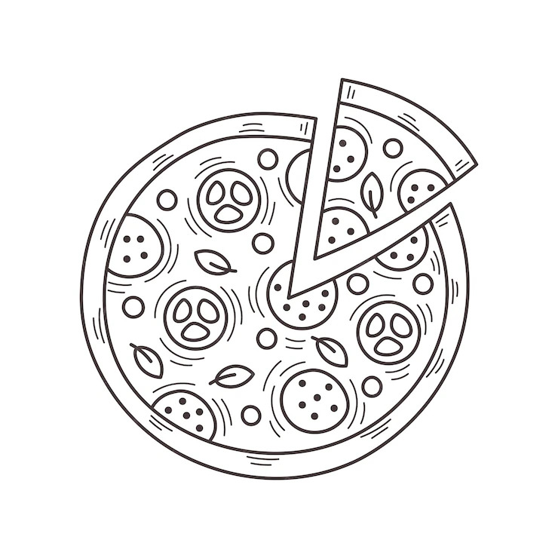
2. What is the circumference of Mr. Slice's pizzas?
3. If Mr. Slice cuts each pizza into 8 equal slices, what is the central angle of each slice?
4. Mr. Slice wants to create a new pizza size with a circumference of 18 inches. What would be the diameter of this new pizza?
5. **Case Study 2: The Ferris Wheel**

The local amusement park has a Ferris wheel with a radius of 20 meters. The wheel makes one complete revolution in 5 minutes.

1. What is the circumference of the Ferris wheel?
2. How far does a rider travel in one revolution?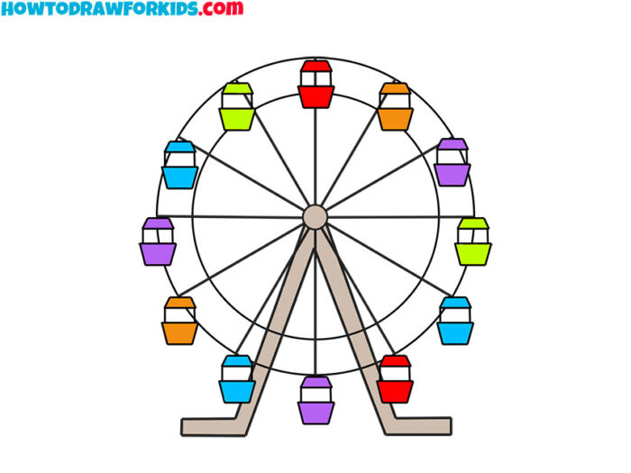
3. If a rider gets on the Ferris wheel at the bottom, how high is the rider after 2 minutes?
4. What is the angle of rotation of the Ferris wheel in 1 minute?

**Case Study 3: The Circular Garden**

Mrs. Green has a circular garden with a diameter of 10 meters. She wants to put a path around the

garden.

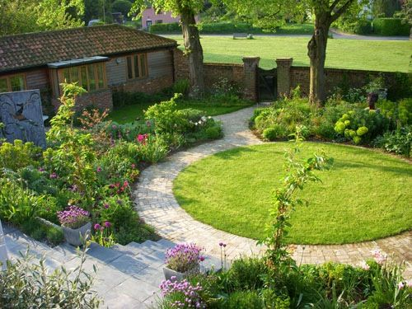

1. What is the area of Mrs. Green's garden?
2. If Mrs. Green wants to put a fence around the garden, how much fencing will she need?
3. Mrs. Green wants to plant a tree in the center of the garden. How far is the tree from the edge of the garden?
4. Mrs. Green wants to divide the garden into 4 equal sections. How can she do this?

**Case Study 4: The Bicycle Wheel**

A bicycle wheel has a radius of 30 centimeters. The wheel makes 2 revolutions per second.

1. What is the circumference of the bicycle wheel?
2. How far does the bicycle travel in 1 minute?
3. If the bicycle wheel makes 100 revolutions, how far has the bicycle traveled?
4. What is the angular velocity of the bicycle wheel in radians per second?

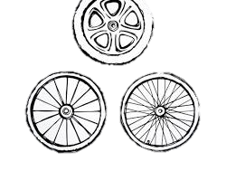

**Case Study 5: The Clock**

A clock has a minute hand that is 10 centimeters long. 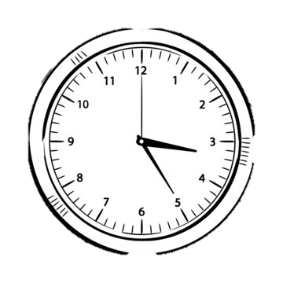

1. What is the distance traveled by the tip of the minute hand in 1 hour?
2. What is the angle swept out by the minute hand in 20 minutes?
3. At what time is the minute hand pointing directly east?
4. If the hour hand is pointing at 3 o'clock, what is the angle between the hour hand and the minute hand?